,=

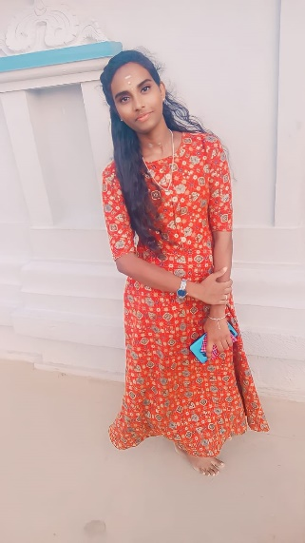

SINDHU M

# Contact:-

**Receiver with solid fill:**+91 6374441283

**Envelope with solid fill:** [msindhu1005@gmail.com](mailto:msindhu1005@gmail.com)

**:** <https://tinyurl.com/bd9ykwh3>

**:** <https://tinyurl.com/kpzfkych>

# Address:-

# 1460, Mendela nagar

# Gandarvakkottai ,Gandarvakkottai (T.K)

# Pudukkottai (D.T)

# Education:-

## M .Sc Computer Science

## RVS College of Arts and Science, Coimbatore

* Pursuing.

## Bachelor of Science in Computer Science (BSc CS)

Government College of Arts and Science –

Karambakudi

* From 2020 to 2023
* 79%

## Higher Secondary

Government Girls Higher Secondary School-

Gandaravakkottai

* From 2019 to 2020
* 78%

## SSLC

Government Girls Higher Secondary School -

Gandaravakkottai

* From 2017 to 2018
* 76%

# Hobbies:-

# Cooking

# Playing

# Career Objective:-

To use my extensive knowledge of software engineering, innovative problem-solving skills, and passion for technology to develop and implement high-quality software solutions and contribute to the success of the organization.

**Skills:-**

## Front-End:- Database:-

HTML |CSS | JAVASCRIPT

## Languages:-

* Tamil
* English

**Self Declaration:**

I here by declare that the above information is correct and true to be of my knowledge and believe

SINDHU M